Part 1. Getting started

Setting up Visual Studio Code
To work with StoryScript effectively, you should use an editor that supports you in creating your game components like HTML and TypeScript files. A good choice is Visual Studio Code. This is a product related to the full-fledged Visual Studio, but much more lightweight and, more important, also available on operating systems other than Microsoft Windows. Of course, you can also use the full Visual Studio if you want.
This tutorial will assume you are using Visual Studio Code, and it will help you set it up for Windows. The first step is to download and install it. Go to https://code.visualstudio.com/download and download and install the program (the default settings are fine if you are unsure what to choose when you are presented with options).
Once done, you will also need to install NodeJs to be able to build and run your game. Download it from https://nodejs.org/en/ and run the installer.
Now that you have your development environment set up, it is time to get the StoryScript code from GitHub. Navigate to https://github.com/StrixIT/StoryScript, click 'clone or download' and click the ‘Download ZIP’ button (we’ll use this to get started fastest, you can also clone the repository and create your own branch if you want):
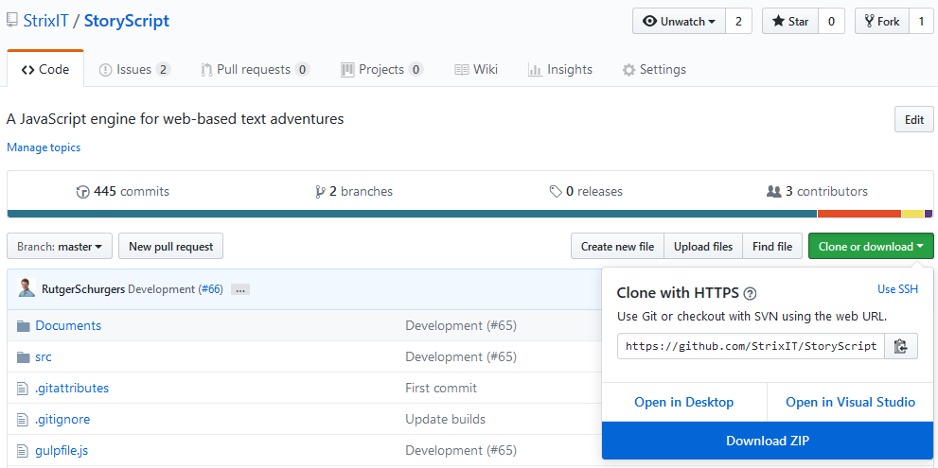
Extract the contents of the StoryScript-master folder to a folder called StoryScript on your hard drive. Then start Visual Studio Code. From within Code, open the StoryScript folder via File → Open folder:
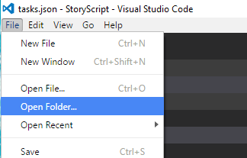
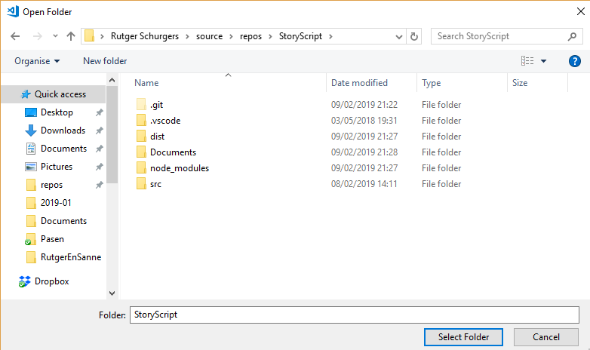
You should see the StoryScript folder open in your explorer on the left:
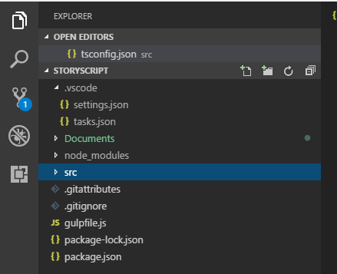
Great, now just one more step before you are all set up! Open the integrated development console by pressing CONTROL and '`' at the same time. Then install all the required packages by typing 'npm install' (enter). Wait until the installation is done. Now, you can finally start working on your game!

Decide what type of game you want to build
StoryScript started out as a simple engine for interactive stories, which basically are stories in which you as a reader make choices from time to time. From there, it expanded to support much more. You can now also create role playing games and adventure games with it.

StoryScript comes with several screen components that make up your game. Not all components make sense for all types of games. For example, in an interactive story you wouldn’t need an equipment screen, and probably can also do without a backpack and most other additions needed for creating games that are more than stories with choices. It is easiest to get started by focusing on just the components you need. You can always add more components later when they are required after all.

In this tutorial, we’ll be creating a few example games, starting with a simple interactive story. This will introduce some critical concepts that you need to understand for creating any StoryScript game. Having done that, we’ll move on to creating first adventure and then role playing games.

Creating a new game
When creating a new game, you need to select either a basic interactive story setup or a standard setup. Apart from this, the process of creating a new game and starting it for the first time is similar so we’ll cover it once here before moving on to discussing the different types of games.
To start working on a new StoryScript game, first choose a name for it, without spaces or special characters. Let's use MyInteractiveStory as an example.
Open the tsconfig.json file in the src/Games folder of the StoryScript project and change the line '"./_GameTemplate/**/*.ts",' to '"./MyInteractiveStory/**/*.ts",':
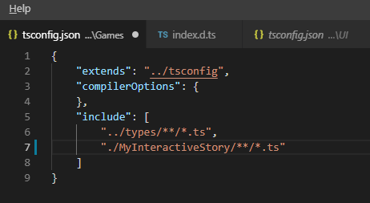
With that setup in place, go to the Terminal menu and select Run Task…:
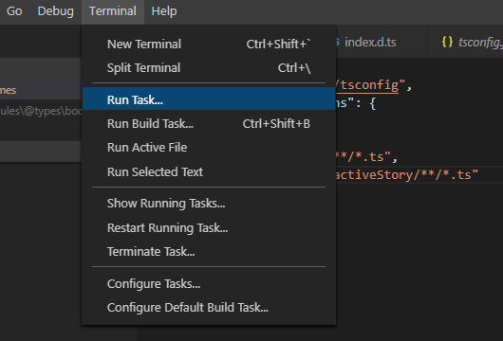
From the list, click ‘gulp:create-game-basic’ to create a new interactive story (use the ‘gulp:create-game’ task for a standard setup):
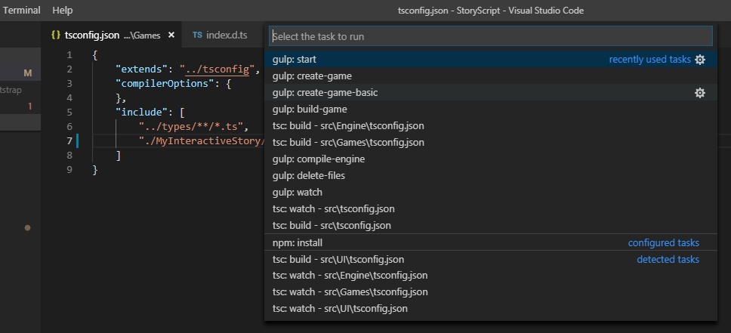
This should run the create task and a new folder with your game should appear in the Games folder:
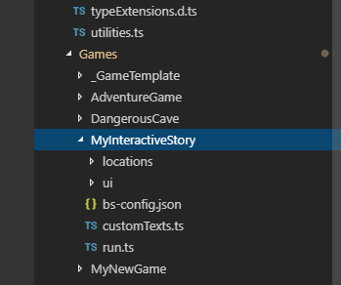
You should now be able to build and run your game. Configure your default build task using the Configure Tasks from the Terminal menu:
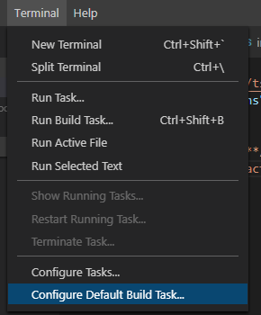
There, select the ‘gulp:start’ task:
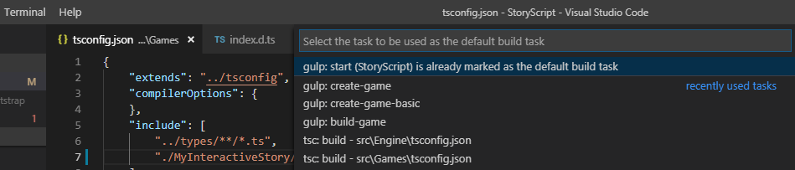
Your tasks.json should open, showing you something like this:
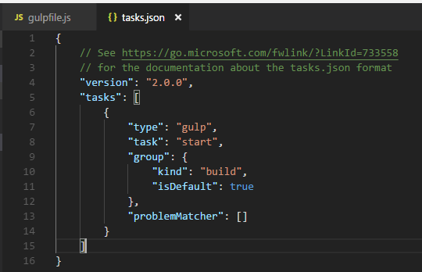
Then, press 'CONTROL-SHIFT-B' to build and run the game. You should see this output in the integrated terminal:
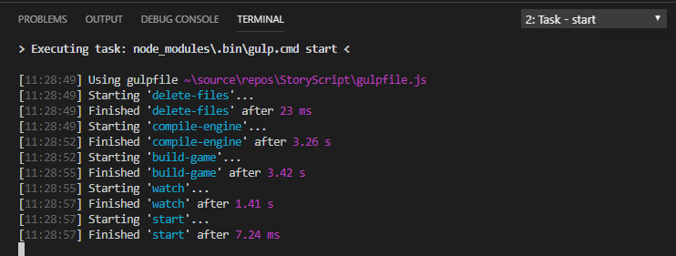
Google Chrome should launch, showing you something like this (a standard game has more components active):
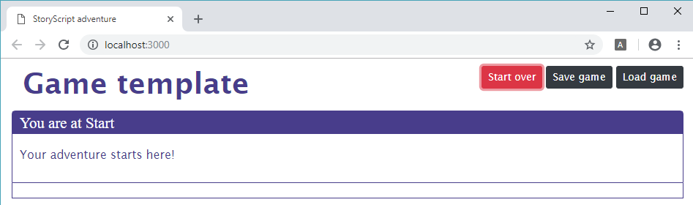
If you don't have Chrome, you can change the browser used in the 'bs-config.json' file in your game folder to e.g. FireFox:
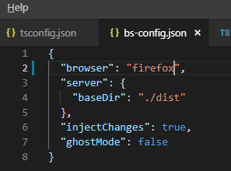
Congratulations, you are ready to begin creating your new game! Note that your browser will refresh whenever you save changes to your files (for css, the changes will be applied even without a refresh). You can enable automatic saving of files via the settings menu:
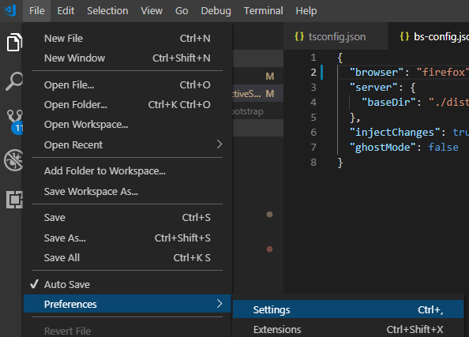
Change the contents of your 'User Settings' to match the screenshot below. You can of course change the Auto Save Delay to suit your preference:
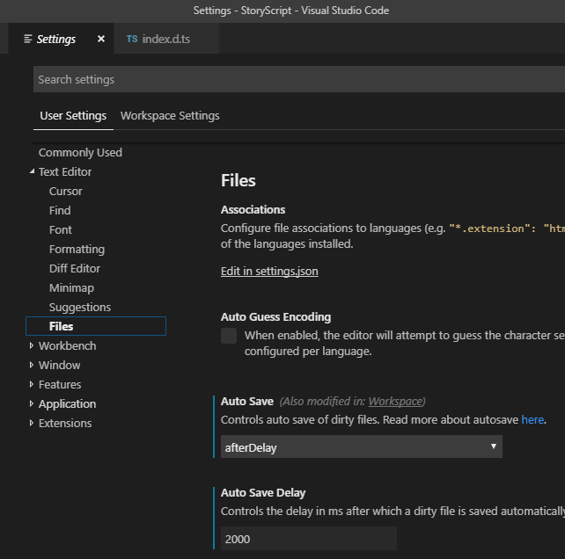
Now, whenever a file is added, changed or deleted, the browser will refresh showing you the latest version of your game.
IMPORTANT NOTE: this is true for everything you need for interactive stories. All changes to css, html and resource files should be reflected immediately in the browser. If you move on to more dynamic games using standard mode, things are a bit more complicated, as explained in part 3.

Customizing your user interface
With the structure of your game in place, let’s start by changing the UI a bit to make it more specific to our game. I’ll be showing you some basic ways in which you can do this using custom texts, html, css and resources. As StoryScript leverages basic browser technologies, you can use anything available in html and css to make it feel, look and sound as you want. So you can change font type, but also show pictures or play video.
We’ll begin by changing some of the interface texts you are seeing. For example, the display name of your game is still 'Game template', and maybe we want to show 'Chapter Start' instead of 'You are at Start' (Start is actually the name of the first chapter, we can give it a different name later).

To change UI texts, go to the customTexts.ts file in your game folder. Place your cursor one line below where it says 'Add your custom texts here' and press CONTROL-SPACE. You will now see a list of all the texts that you can personalize:

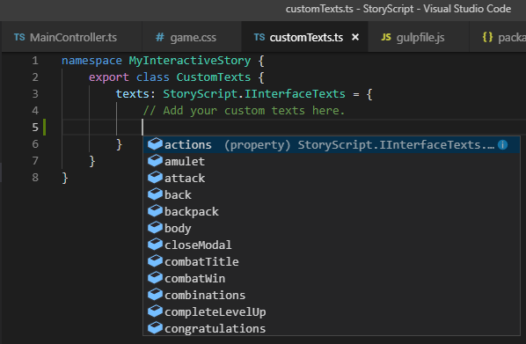
Change the game name and chapter texts by adding the following code. Note the placeholder for the chapter name:
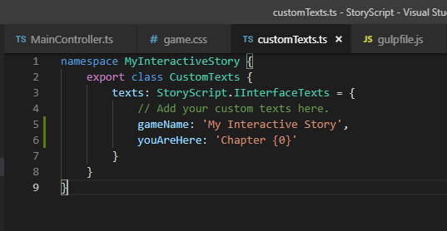
Your browser should now display the new texts.

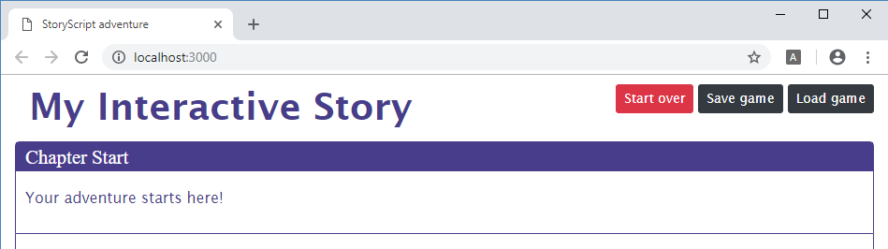
With that done, let’s do some simple styling changes to illustrate how you can use CSS and image resources to change your game’s appearance. Open the ‘game.css’ file in the ui folder and make some changes like below:

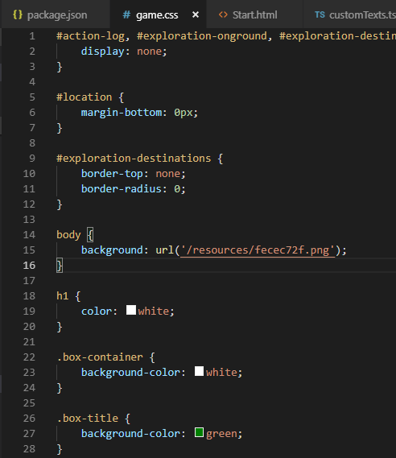

I added a background I randomly generated using http://bg.siteorigin.com/ to the resources folder in my game directory and referenced it in the css file for use as background picture. I also changed some colors. Your browser will show you the changes without a refresh:

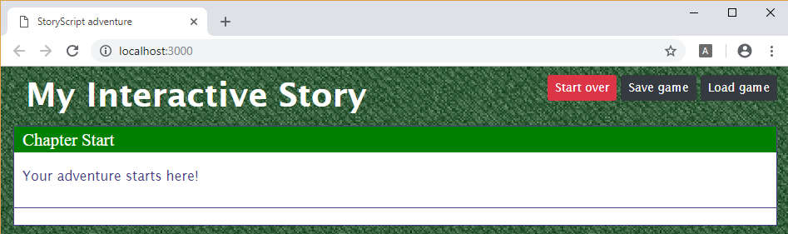

Enough on this for now. I’ll reset the styling to the defaults for the rest of the tutorial.

Part 2. An interactive story

Adding text and choices
Now that we have our UI set up, let’s write the first chapter of our interactive novel and give the reader some choices. Just as with the UI, you can use everything a browser supports in your novel as you’ll be using HTML markup to structure your content. But let’s first focus on simple text. Open up the Start.html in the locations folder. It has the text you currently see:

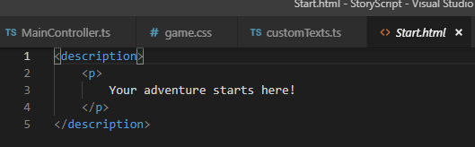

Let’s change it to contain a few paragraphs:

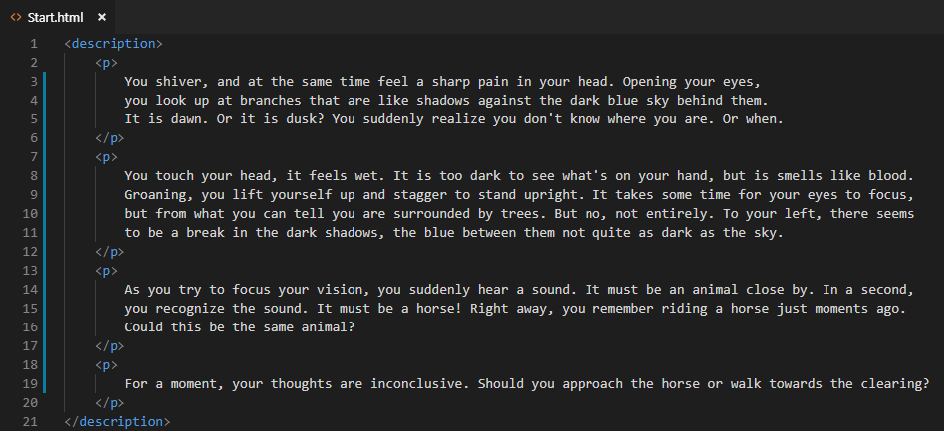

When you save, your browser refreshes to show you your new text:

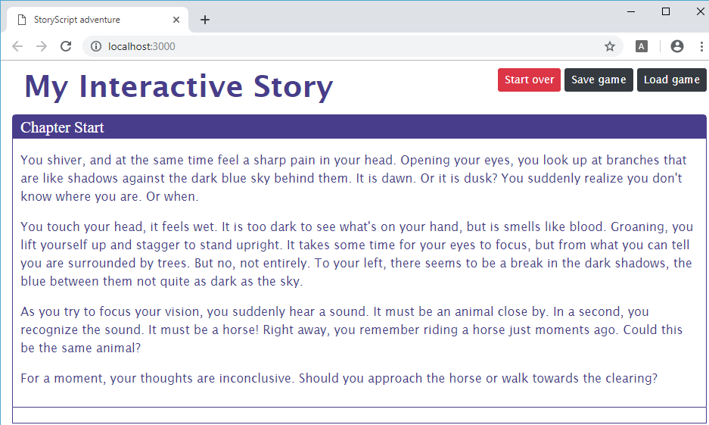

Right. Now we want to change our chapter name, as Start isn’t very appealing. For this we’ll use the displayname attribute of the description of the Start.html file:

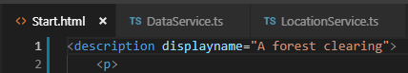

You should now see:


With the opening chapter name and text in place, we want the reader to be able to make a choice. For this, we add destinations to our HTML files. Each choice is represented by a destination, which leads to a new part of your story (a new HTML file). Currently, the story tells about a choice between two alternatives, so we need to add in two destinations, like this:

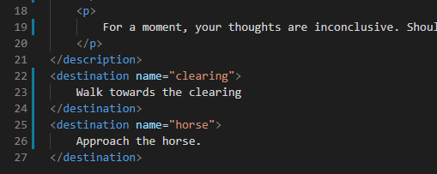

As soon as you add destinations this way, your browser will show them to you although at first they are unavailable:

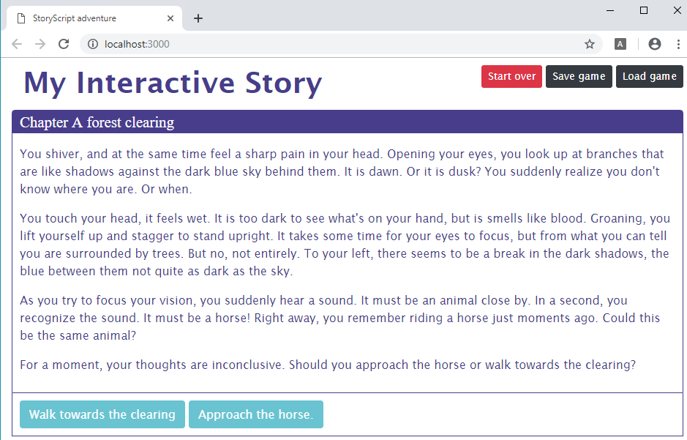

As you didn’t add either a clearing.html or a horse.html file yet, there is nothing to continue reading so nothing to switch to. As soon as you add either of these files, the corresponding destination button will be activated:

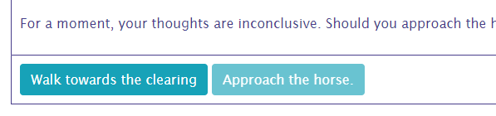
Add a piece of story to the clearing.html and click the button. You now see the new piece of the story displayed:
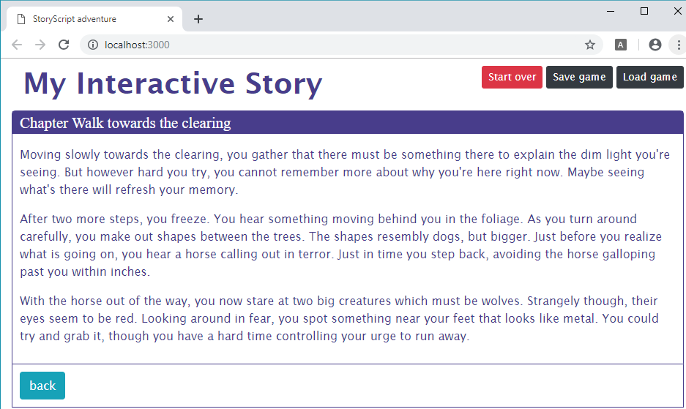

Notice that a back button is available automatically to help you test your story more quickly. If you don’t want it to show (like when the story is done), you can use some CSS to hide easily hide it:

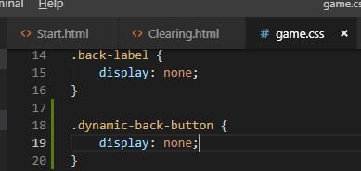

You can also use the start over button to jump right back to the start of your game, and use the save game and load game buttons to store a game state and go right back to it. In an interactive story that may be not that interesting, but when you create more advanced game types this is definitely a nice thing to have.

Adding media
When you have a story to tell, you can write it in StoryScript. But often, you may want to use more than just text. In books, pictures can help bring the story to life. And when you have the web browser at your disposal, you can also use audio and video. All of this is entirely optional, and creating media of these types is an art you may not master (I know I don’t). But when you can create your own pictures or music, or when you have someone working with you that can, you can use those in StoryScript.
Basically, it is as simple as including pictures, audio and video in your descriptions with the usual HTML tags (<audio> and <video>). StoryScript will help to start playing them automatically, once or repeatedly (useful for background music). As an example, let’s add a picture and some background music to our first chapter. I’m adding a picture and audio, as well as aligning the picture to the text, changing the start.html file like this like this:
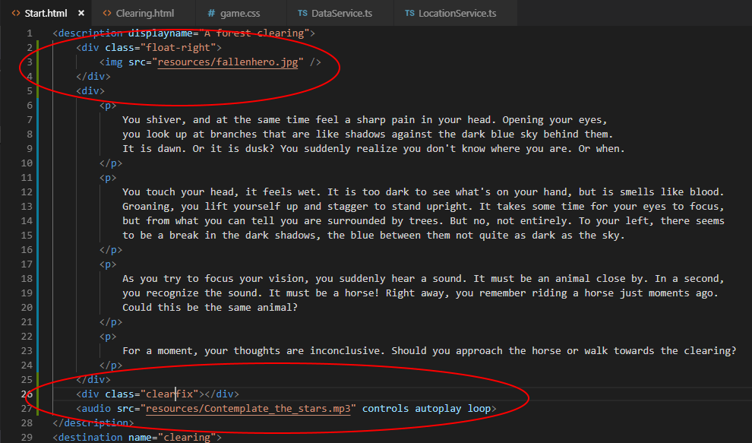
When your browser refreshes, you should now see this and hear the music play:
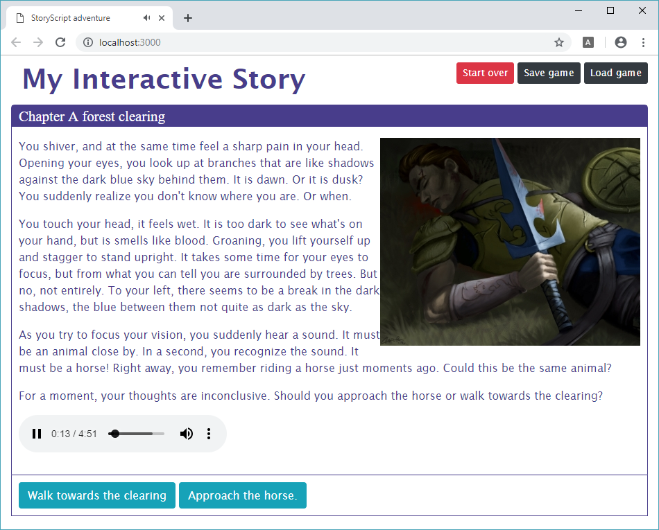
You can hide the audio controls if you want by just removing the controls attribute from the audio tag.

Part 3. Adventure gaming

Setting up a standard game
In the early days of adventure gaming, classics such as King's Quest and Monkey Island defined the point & click adventure in which you wander the game world solving riddles by combining items, using them on characters or objects etc. Riddles like these can be created in StoryScript using combinations.
Working with combinations requires you to use a standard StoryScript game. While you could write an interactive story without any programming skills, creating an adventure game with combinations will require you to get your feet wet with some TypeScript programming. TypeScript is a superset of JavaScript, but that is not that important here. I’ve tried to make the StoryScript programming interface (Application Programming Interface or API) as simple to use as possible. That said, all programming requires some getting used to. If you stick with it, though, it gives you a lot of power to create unique games.
First, stop your interactive story game if it is still running by putting the focus in the console and pressing CONTROL-C and then Y:
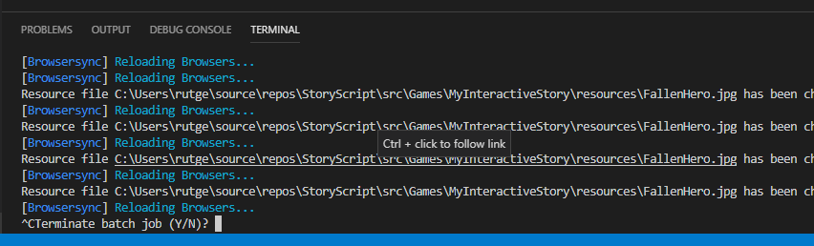
Create a new game called AdventureGame by changing the tsconfig.json file in the Games folder:
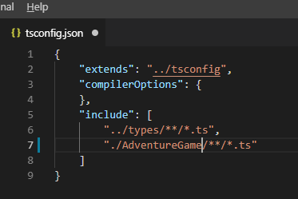
Then from the terminal menu, run the gulp:create-game task:
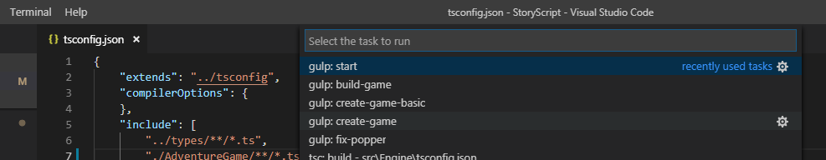
Your new game is created, which has more files than a basic game:
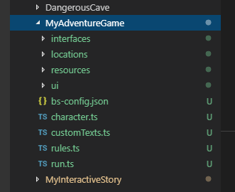
When you build and run it (CONTROL-SHIFT-B) and your browser opens, press the Start over button. Your new game should look like this:
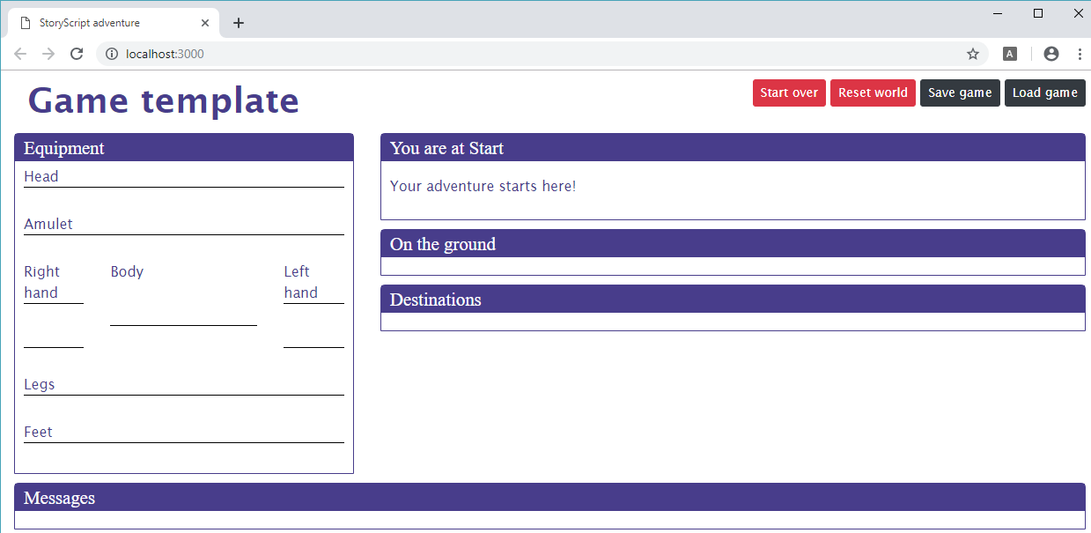
If it doesn’t, press either the Start over or the Reset world button.
IMPORTANT NOTE: for standard games, it is no longer sufficient to just let the browser refresh to see all your changes. HTML and CSS changes should still be visible right away, but changes you make in .ts files (TypeScript files) will not show up immediately. This is because the game state is persisted between browser refreshes. It is one thing to display new text, styling or pictures right away, but resetting the game state on each refresh would be very annoying. That would mean that e.g. enemies and items are reset on each refresh. For changes made to your .ts files to show up, you need to press the Reset world button. From now on, when your browser refresh doesn’t show you your latest changes, please press the Reset world button to make them appear.
Ok, now let’s change the interface a bit to show just the parts we need for our adventure game. We don’t need the equipment screen, we’ll only be using the backpack (shown automatically when we find items). Simply open the character.ts file in your game folder and clear out the character properties:
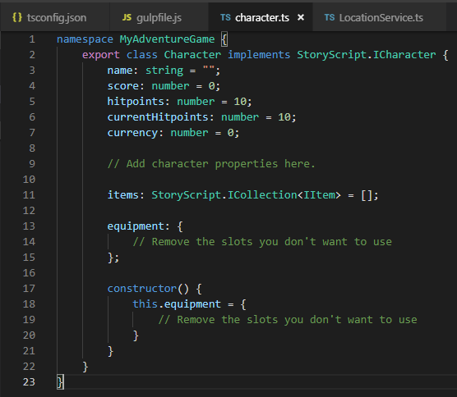
When the browser refreshes, press the Start over button so the character is refreshed and the equipment part goes away:
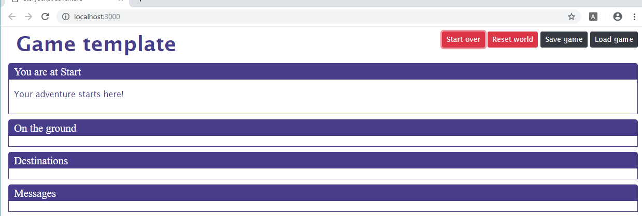
Ok, we’ll work with these elements for now. Time to start defining our combinations.

Using combinations
Defining what combinations should be available in the game is done in your rules.ts file. Let's define 'Use', 'Touch' and 'Look at' for this example. First, create a new constants.ts file with these contents, so we define our combinations in one place:
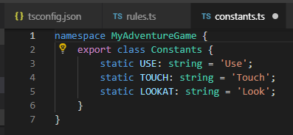
We can use these definitions to create the combinations in our rules.ts file like this:
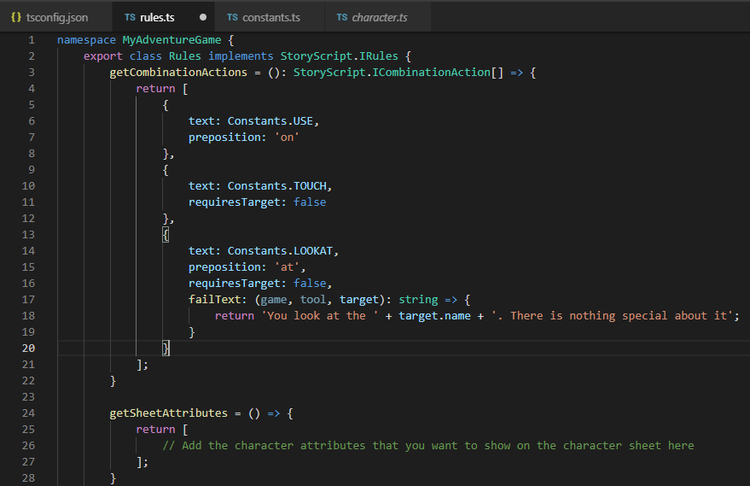
There are a few things to note here:
- You can see that the combinations have an action text (e.g. 'Use', 'Look') and an optional preposition ('on' or 'at'). In StoryScript, these will be used to create combinations such as ‘Use pen on paper’ or ‘Look at gate’.
- As some combinations do not require two parts (Use does, but Look does not (of course, you could also use binoculars to get a better look, but you get the idea)) you should specify when one does not require a target.
- You can specify a default text displayed when a combination is tried that doesn’t work in the customTexts.ts file. There are two templates you can override, one for combinations requiring a target and one for those who don’t:
noCombination: "You {2} the {0} {3} the {1}. Nothing happens."
noCombinationNoTarget: "You {1} {2} the {0}. Nothing happens."
If you want something more specific, you can specify a fail text per combination, as shown above. You can be even more specific when you know what combination is tried on what object, which will be discussed in a bit.

Part 4. Role playing games

Define your hero
Next, you want to let the player create a hero with whom to play the game. To determine what such a hero looks like, open the character.ts file in your game's folder. You can add properties where it says so. Say we want to measure our hero's strength, agility and intelligence, which start at 1 and max out at 10 (we do not do anything to enforce that yet). We then add:
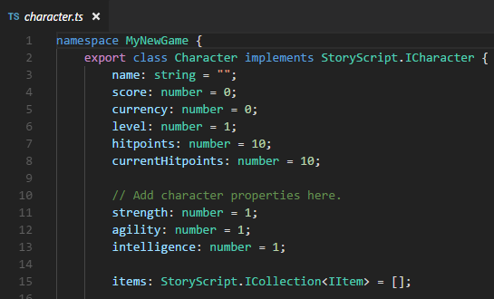
Next, we need to choose the equipment slots that we will use. You can enable these slots (the list can be reviewed in the StoryScript folder, character.ts file):
head, body, hands, leftHand, leftRing, rightHand, rightRing, legs, feet.
Let's use head, body, left and right hands and feet only. We define this by populating the character's equipment object like this:
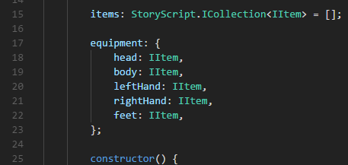
Now, we want the player to make some choices when creating the hero that will determine his or her starting stats. For this we need to define the character creation process. Open the rules.ts file in your game's folder and find the line that says “Add the character creation steps here”. We will ask the player what name he wants to give to his character and ask two questions, showing the second question only after he answered the first. To do that, we'll create three steps (if we wanted to show both questions at the same time, we would define only two steps, one for the name and one containing both questions). The required code is listed below:
getCreateCharacterSheet = (): StoryScript.ICreateCharacter => {
return {
steps: [
{
attributes: [
{
question: 'What is your name?',
entries: [
{
attribute: 'name'
}
]
}
]
},
{
questions: [
{
question: 'As a child, you were always...',
entries: [
{
text: 'strong in fights',
value: 'strength',
bonus: 1
},
{
text: 'a fast runner',
value: 'agility',
bonus: 1
},
{
text: 'a curious reader',
value: 'intelligence',
bonus: 1
}
]
}
]
},
{
questions: [
{
question: 'When time came to become an apprentice, you chose to..',
entries: [
{
text: 'become a guard',
value: 'strength',
bonus: 1
},
{
text: 'learn about locks',
value: 'agility',
bonus: 1
},
{
text: 'go to magic school',
value: 'intelligence',
bonus: 1
}
]
}
]
}
]
};
}

Go back to your browser, which should have refreshed now. After entering a name, you should see the first question with the three options you defined:

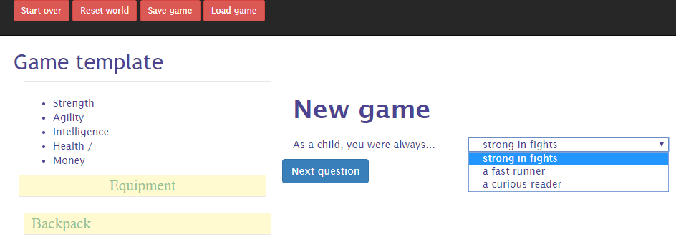
When you're done creating your character, you'll want to display some vital statistics in the character sheet on the left-hand side of the screen. You can specify which character attributes to list in the rules. Let's add the three attributes we defined. Health and money will be displayed by default:

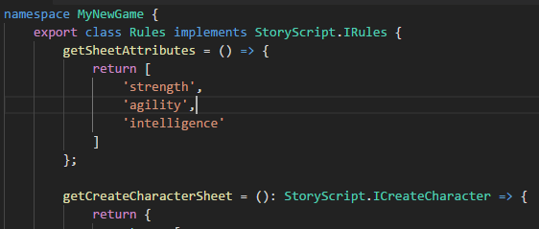
When you finished character creation, you should now see something like this:

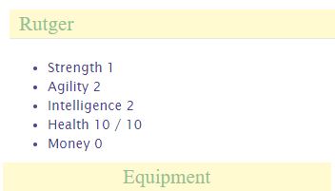

Personalize the interface texts
Now is a good time to change some of the interface texts you are seeing. For example, the display name of your game is still 'Game template', and maybe we want to show 'Create your character' instead of 'New game'. There are three ways in which you can change the interface, and changing just the texts is easy and done via the customTexts.ts file in your game folder. The other ways are changing the game styling and customizing display templates, both of which are discussed later in this document.
Open your customTexts.ts file, place your cursor one line below where it says 'Add your custom texts here' and press CONTROL-SPACE. You will now see a list of all the texts that you can personalize:
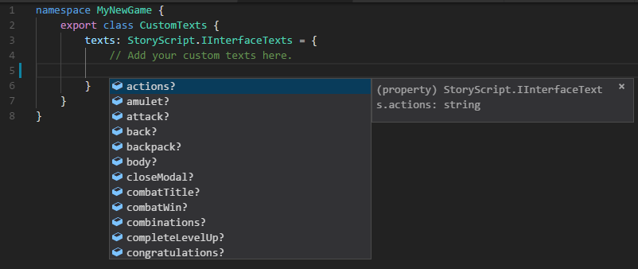
Change the game name and new game texts by adding the following code:
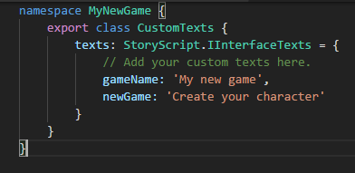
Your browser should now display the new texts.

Locations

Change a location's name and description
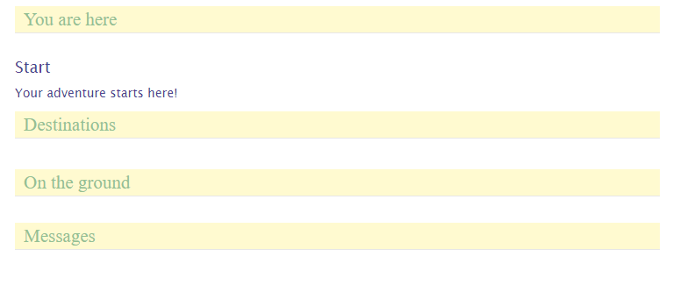
When we create our character, there's nothing for us to do right now. Our adventure window shows very little:
First, you can change the text displayed under 'You are here' by modifying your currenty only location, Start. Open the locations folder under your game folder and you will see a Start.html file and start.ts file underneath.
To change the 'Start' text, open the start.ts file and change the name property in the file, for example to 'Home'. The description of the location ('Your adventure starts here') is in the Start.html file. In that file, you can see a <description> tag containing the text. Let's change it to 'You are at home. Let's get started.'
Your browser should update and show:
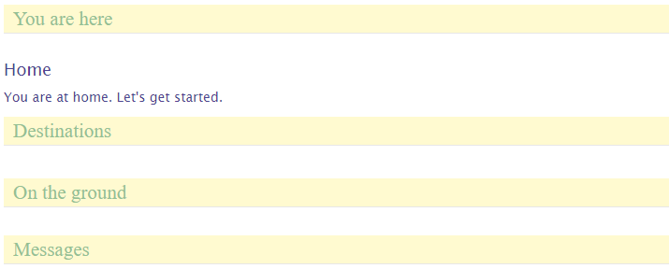

Multiple descriptions for varying circumstances
A nice feature is that you can have multiple descriptions in a location's .html file that you can choose from while running the game. As an example, let's make it so that the location description changes depending on the time of day, with a text for daytime and a text for night time. To do this, you need to repeat the <description> tag and add an attribute to the second tag that you will use to select it, for example 'night'. Our Start.html will then look like this:
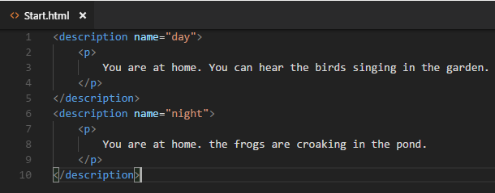

To actually show the night time description between 6 p.m. And 6 a.m., we need to create a selector in our location's .ts file. Modify your start.ts like this:
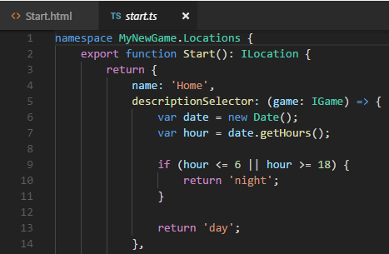
Now, depending on your local time, you see either:

Or:


Adding new locations
Now that we are happy with our start location, let's allow the player to go somewhere. We'll add to new locations, the hero's garden behind his home and the dirt road in front of it. The easiest way to do so is just to copy Start.html twice and rename the copies. The result should look like this:
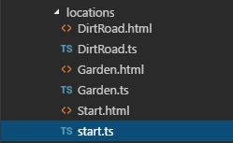
Open both the new .ts files, change the name properties and remove the description selectors. Also change the function names to match the file names (not required, you can select another name as long as it does not have spaces or special characters). Your Garden.ts should look like this:

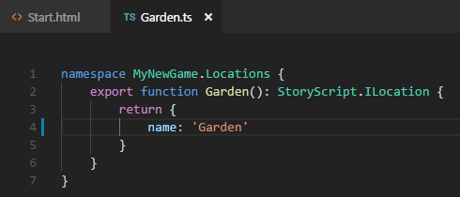
And your DirtRoad.ts similar, with a different name and function name of course.
Next, change your .html files to add some proper descriptions. We use just one description for now, so please remove the name attribute from the description tag. My Garden.html looks like this:
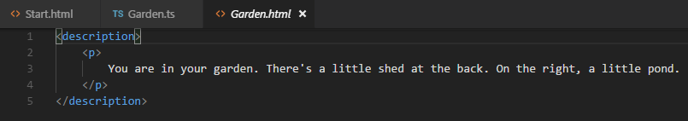

Linking locations
Allright, now we have three locations but no way to reach the new locations yet. To connect locations, open a location's .ts file and add a destinations property. We'll do so in the Start.ts file. The player should be able to go to the garden or the dirt road from the start location.
Start by adding a destinations array and a first destination object. A destination has a text (this is shown in the interface under the destinations header) and a target, the actual destination. Note that when you create the target and you typed Locations and entered the dot, visual studio will show you all your locations so you can easily pick the one you want:
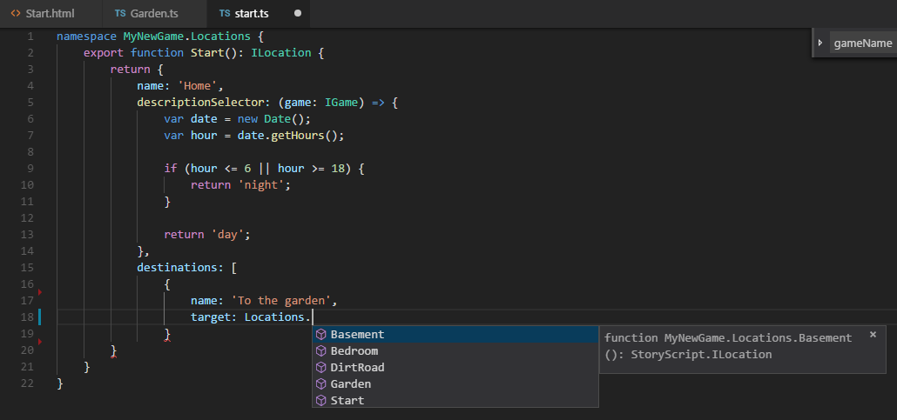
When you added both destinations, your destinations code looks something like this:
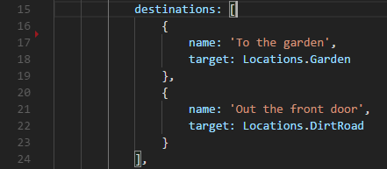
When your browser reloaded, click 'Reset world'. Then you should see this:
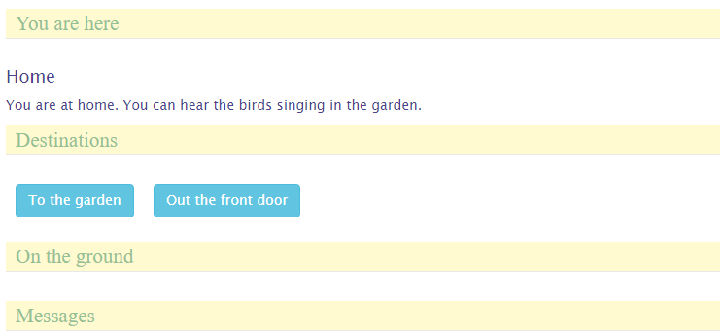
Clicking one of the buttons should take you to that location. Note that now you are stuck because you have not defined the navigation the other way around. Do that, click 'Start over' and walk around your three-stage world.

Items
Going out there without decent gear will cut any adventuring career short. Let's add some basic items for our hero to pick up at his home. Add two new files to the items folder in your game folder. Add sword.ts and leatherBoots.ts. They should look like this:
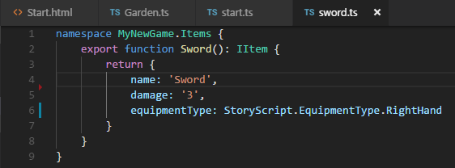
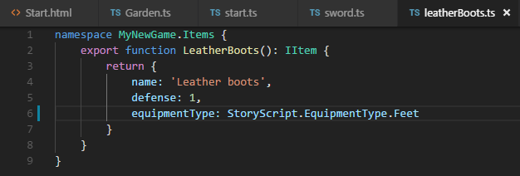
Ok, now that we have the items, we need to make them available. Add them both to the starting location by modifying your Start.ts, like so:
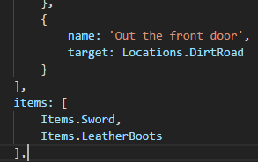
Click 'Reset world'. When you go to your home, you should see:
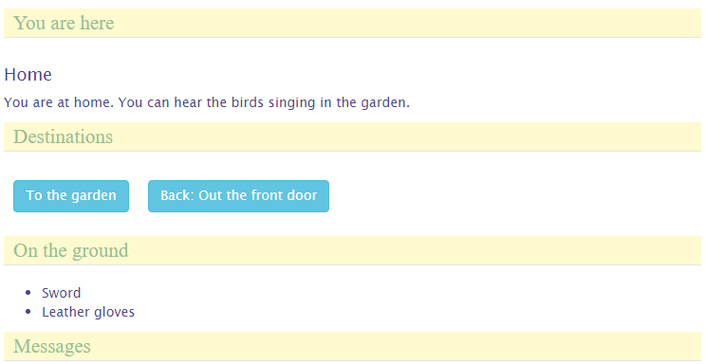
You can pick up these items by clicking them, and you can then equip them or drop them again.

Events
Let's now enhance our walking around experience a bit by adding an event to our garden. Events are anything you can think of that happen once, when the player first enters a new location or leaves first leaves one. We'll do something very simple and just write a message to the log. Modify your Garden.ts like this:
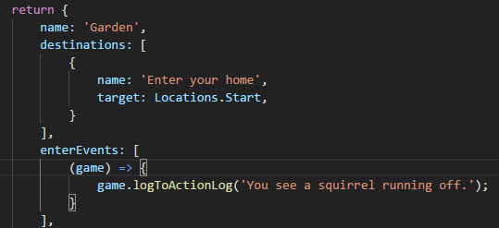
Reset the game and go to the garden. The first time you go there (and first time only), you should see the message appearing under 'Messages':
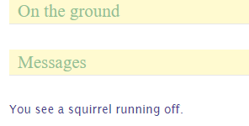
This is of course rather trivial, but events can be used for powerful stuff as you have the full game API at your disposal in the event function. Check out the API documentation once you feel comfortable enough with the StoryScript concepts described in this tutorial.

Enemies
Let's give the hero an opportunity to be heroic by adding a bandit to the dirt road which he can fight. First, add a new bandit.ts file to the enemies folder in your game folder. It should look like this:
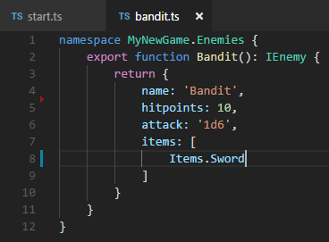
Note that I gave the bandit a sword, just like the one our hero can pick up at home. When an enemy is defeated, the items he carries are dropped on the floor in that location.
Now, we need to add the bandit to the dirt road location. Modify DirtRoad.ts like this:
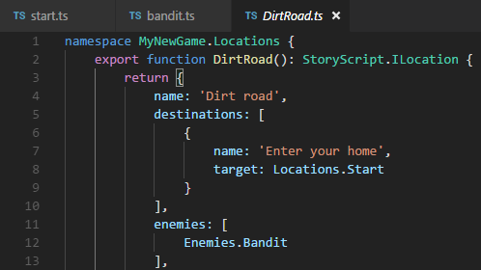
Reset the game. You should see the bandit as you enter the dirt road:
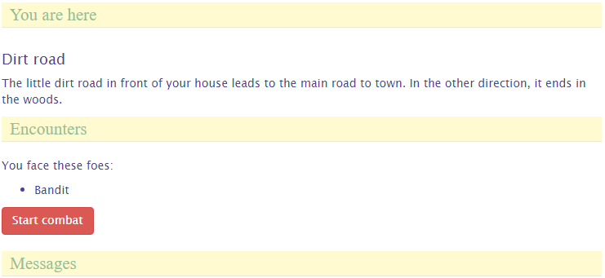

Creating a combat system
When you enter combat and click the Attack Bandit button, nothing happens. That's because there is no default combat system in StoryScript, as combat rules as well as how heroes, enemies and items are defined can vary wildly. You will have to program such a system yourself, which requires some skill with JavaScript and TypeScript.
For now, let's just add a very simple system to experiment with. Open your rules.ts and find the fight method, shown below:
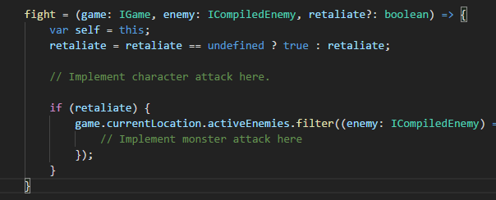
Modify it like this:
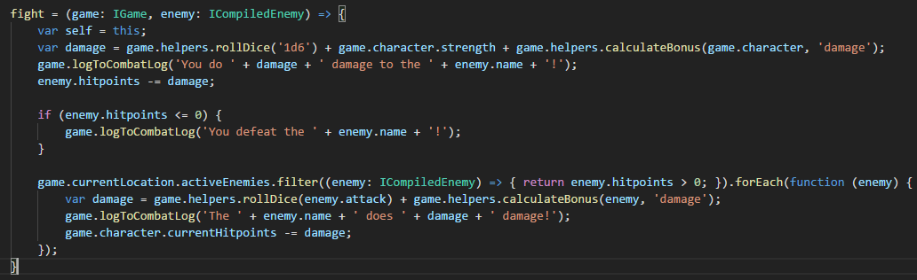
This combat system is very simple. It just rolls a six-sided die for the hero and adds his strength and weapons damage bonus to the result. It writes a message to show the damage done, and subtracts the result from the enemy's hitpoints. When the enemy has 0 or less hitpoints, another message is written and the method exits, returning true for winning combat. If not, the enemy attacks the player in the same way.
Reset and click Attack bandit. You can't lose yet, so after a few clicks the bandit might be defeated and you see something like this:
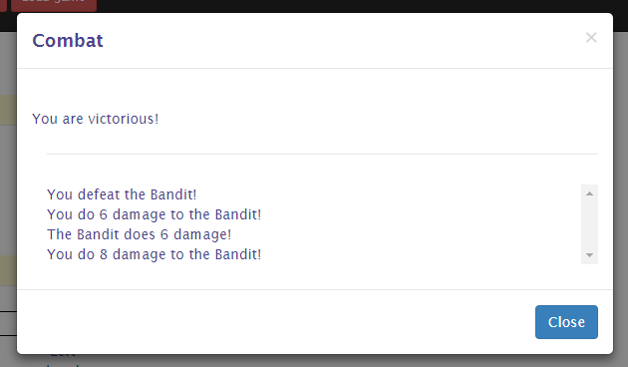
When you click 'Close', notice that the Bandit's sword is now lying on the ground:
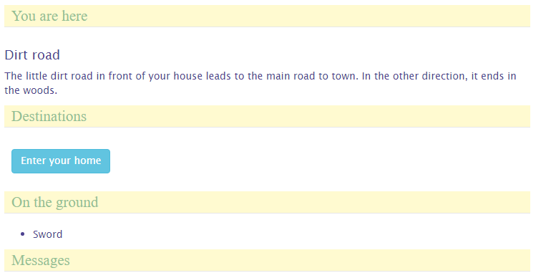
You might also lose, in which case you'll see something like this:


Actions and CombatActions
For the game locations to become interesting, they should offer more than only enemies and events. There should be things to do, buttons to push. That's where actions come in. When you define actions, these will be available at the location after all enemies have been defeated. Examples of actions you might want to add are search, to find more items when the character is alert enough, opening chests, etc.
Let's add two actions to the garden, one to search the shed and one to look in the pond. Add this code to Garden.ts:
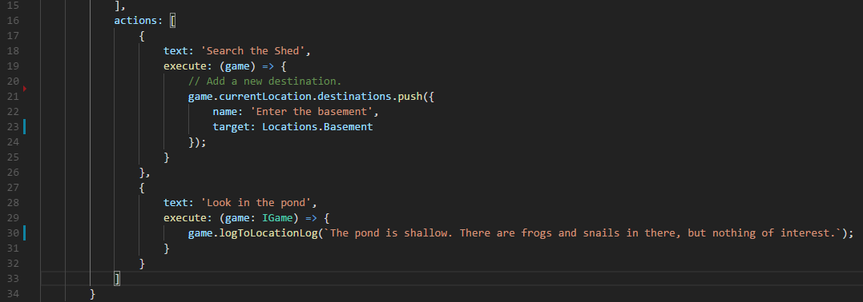
Note that I had to add the Basement location to be able to add the new destination. If you are following along, add that location too.
Reset and you should see the following in the garden:
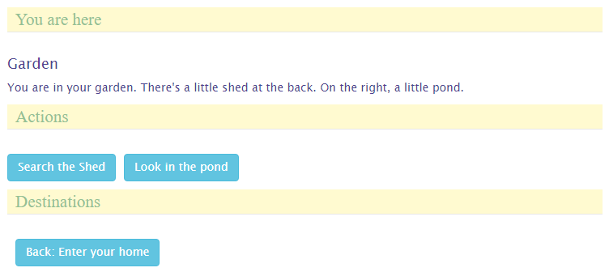
When you press the Search button, a new destination will be added and the Search button removed. Look in the pond will remove the action and write to the location description. If you want to keep the button when it is clicked, have the action's execute method return true (check out the API).
Combat actions are like actions but are available during combat only, when regular actions are not available. Let's allow the hero to run back home when he is afraid to stand up to the bandit. Add this code to DirtRoad.ts:
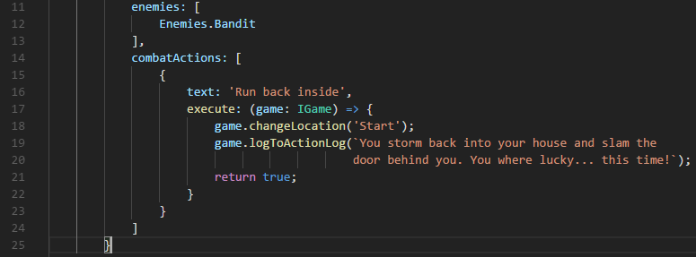
When you go out the door to face the bandit, you should see the option to run back inside. When you take it, you will be told you ran away:
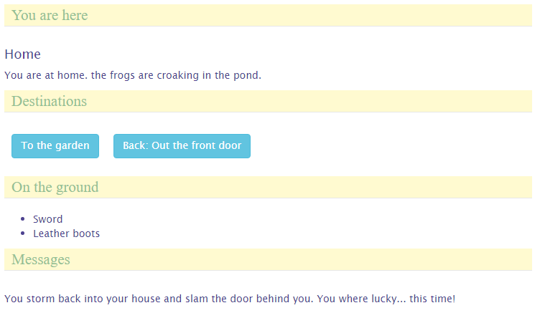

Doors, gates, rivers and other barriers
To make the world more interesting and locations less easy to reach, you can add barriers that impede the hero's progress. Barriers can be anything from doors, locked gates, rivers, chasms or even leaving the atmosphere of a planet.
Barriers are added to destinations, so that it is not simply a matter of moving from one location to the next by pressing a button anymore. As an example, let's add a trap door as a barrier between the garden and the shed basement. Let's leave it unlocked for now, we'll add a required key later.
Open the Garden.ts file and add the following barrier code to the Basement destination:
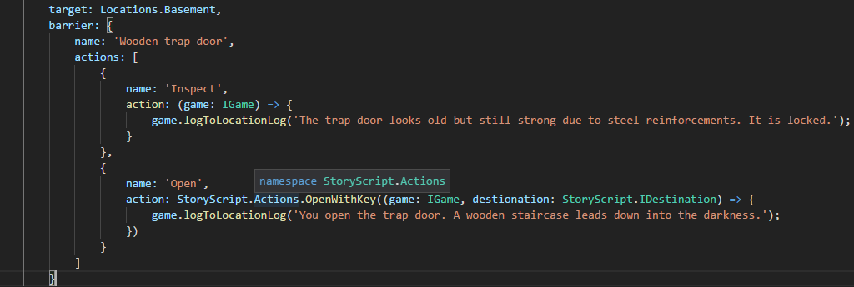
When you run your game and search the shed, the Basement destination should be greyed out because it is blocked by the trap door:
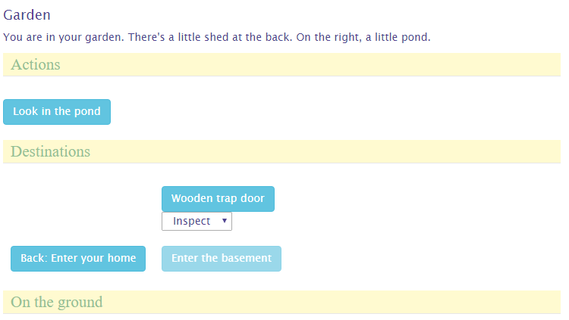

Clicking on the trap door will trigger the action selected in the dropdown. When you leave it at 'Inspect', a message will be written to the location description and the Inspect action will be removed. When the Open action is chosen, the barrier will be removed, including any actions remaining.
Notice that one of the barrier actions uses a StoryScript action, the Open action. You can either define your own method to handle a barrier action or use a default one. This is a far more general comcept that will be explained in a bit more detail in the chapter on the API. For now, notice that you use a StoryScript action and pass it a method that is to be executed (in this case) AFTER performing the default action of opening the door (removing the barrier).
After opening the trap door, the barrier is gone and you can access the basement destination:
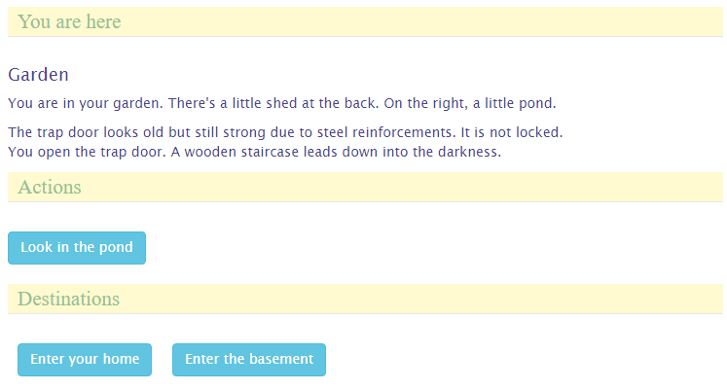
Right. Barriers really make the world more interesting and interactive, but we can add some excitement by requiring the player to acquire the means to pass the barrier before letting him through. In the case of the trap door, this is a key, but you could also require a boat to pass a river or a rocket to travel to another planet, to name just a few possibilities. Let's see how to add that trap door key.
First, add a new item and call it Basement Key (file basementKey.ts):
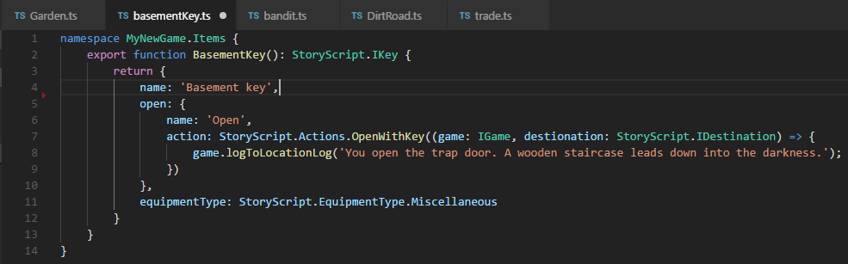
Notice that we again use a standard StoryScript action, OpenWithKey. We pass it the same callback we used for the open action on the barrier.
Now, remove the Open action on the trap door. Instead, define the key required. Replace the barrier code with:
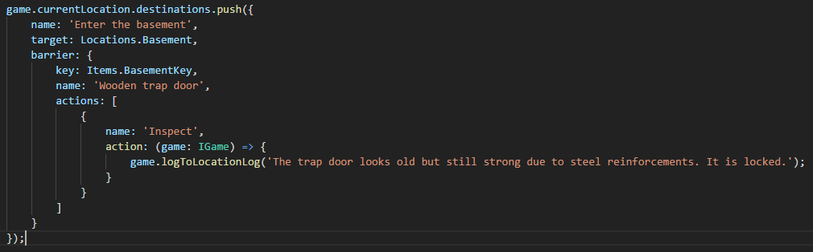

A note on actions added during runtime
In the example above, I added an inspect action at run-time. Because of the way StoryScript handles saving the game state, please be aware that actions added during run-time will be treated slightly different from actions that are present at design-time. Make sure that any actions you add once the game is running are self-contained, meaning they should only reference arguments passed into them or use variables defined in them, and not anything else!

When you run the game, only the inspect action is available on the trap door until you have the basement key in your possession. Let's bring a few things together and give the key to the bandit we added to the dirt road location, so the player will have to defeat him in order to enter the basement:
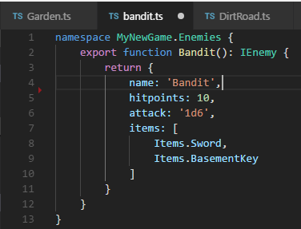
Play the game, defeat the bandit, pick up the key he drops and go to the garden. With the key in your hand, you should now be able to open the trap door again:
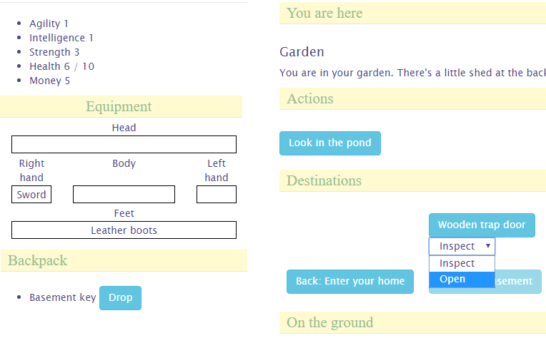
When you open the door, you get to keep the key. If you want to create a use-once key, modify the key like this:
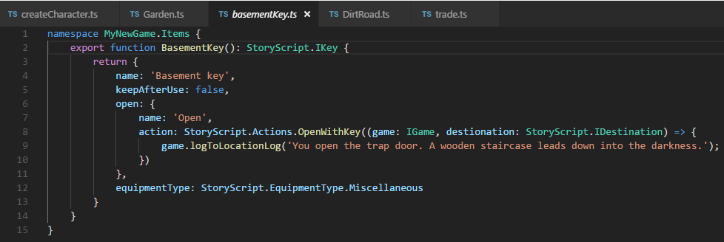

Persons
Not everything moving you meet along the way needs to be hostile to your character. You can also add persons, people (or something else) that you can talk to and/or trade with. You might anger these persons, at which point they can become enemies if you allow this in your game.
We'll add a friend to the game, who is present in your living room. Create a new folder 'persons' under your game folder and add two files to it, friend.html and friend.ts. The html file is very important for persons, as you'll define the conversations you have with them here.
Add this code to the friend.ts file:
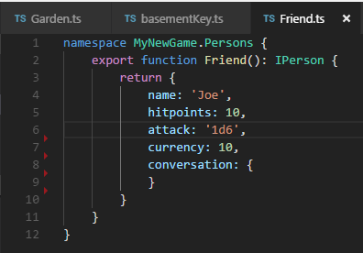
Although the conversation property is now an empty object, it is important that it is there nonetheless as the presence of this property will determine whether or not the engine will try to load the conversation file.
Now that we created the friend, add him to the living room by adding him in the start.ts file:
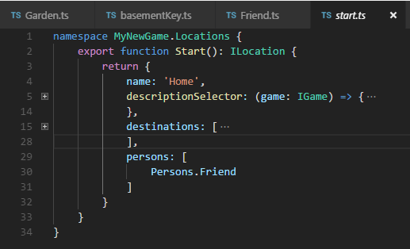
Build and run the game. In the living room, you should now see your friend:
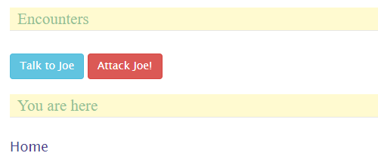
If you don't want to be able to attack Joe, set the canAttack property to false. The attack button will then disappear.
Try talk to Joe. As you haven't given him any lines yet, he has not much to say:
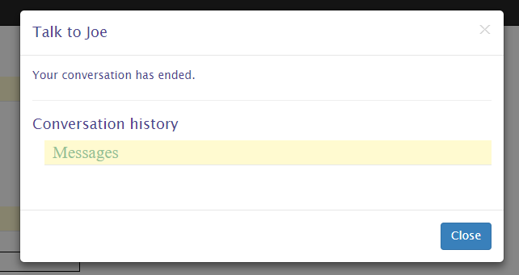
Making Joe a bit more of a conversationalist is the topic of the next chapter. You can interact with persons in more ways, by trading with them or doing assignments (quests) for them. These will be covered in later chapters as well.

Conversations
So we want to be able to chat with Joe a bit. His lines and the replies the player character has available are specified in the friend.html file. Let's start with something simple and add this code to the file:
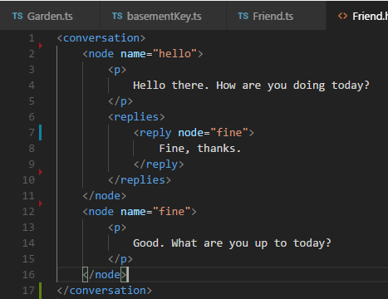
A conversation is made up of nodes. Within a node, you can use all the HTML you want to create a colourful discussion. This html are the lines of the person. You create replies that the player character can use as a response by adding the special <replies> tag and adding child <reply> elements for each available reply.
You can see that there are two nodes in this conversation, and they both have a name. This is very important, as that name is used to link the nodes to each other to create a conversation flow. As you first speak to a person, the engine has a number of ways to determine the node to start with. As we have specified nothing special, the first node, named 'hello', will be used.
So, when you first talk to Joe, he'll ask how you are doing. You can see there is just one reply available right now, saying 'Fine, thanks'. Also, you can see that this reply has an attribute called 'node'. This is used to move to a new node when using that reply. You can see that the name of the node to go to is specified, 'fine'. So selecting this reply will make Joe go on with his lines in the 'fine' node.
Talk to Joe again, choosing the only reply options available right now. The conversation should go like this:
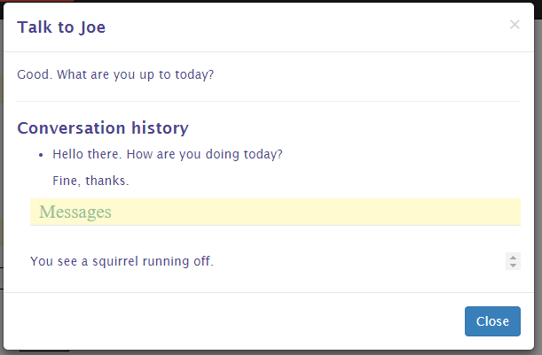
You see that the words exchanged are logged, so you can always review what's been said in case you forget.
You can add in a reply that is available to everything a person has to say by specifying a default response, which will allow you to end the conversation a bit less abruptly:
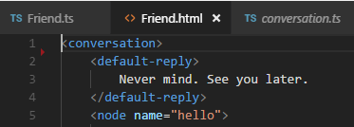
Great, some interactivity! You can expand on this conversation by adding additional nodes and replies linking to these nodes to get a basic conversation going. That's nice, but it wouldn't it be great if the conversation is actually influenced by the things going on in the world around you?
Well, of course we have some options to do this (otherwise it would not make for much of an interactive story). They are:
- Setting a new start node, so the conversation does not start all over again when you re-visit your friend.
- Making replies conditionally available. For example, you could require the character to be witty enough in order to make some remarks.
- Triggering an action when you reply in a certain way.
- Linking your replies to quests.
How quests work with conversations is covered in the chapter on quests. Here, we'll go on to look at the first three options.
Let's first change what Joe has to say when we talk to him again to make him a bit less of an automaton. We do this by adding the 'set-start' attribute to the first reply and adding a new node for his new lines like this:
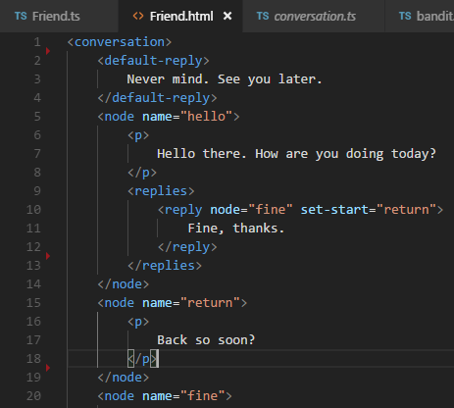
When you now return to Joe, he should have something new in store:
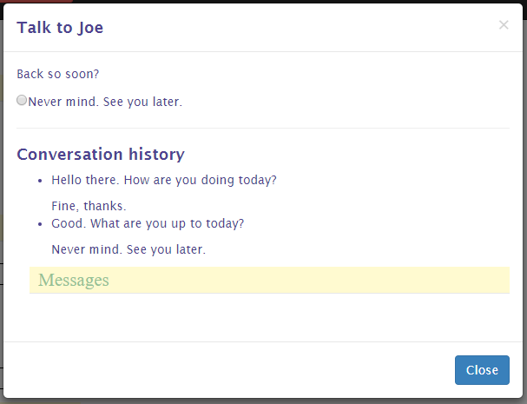

Conditionally available replies
Having replies available only when certain conditions are met is when conversations are getting more interesting and more attuned to what goes on in the game world. For this, you can set the 'requires' attribute on a reply node. You can require a number of things:
- That the player character meet an attribute threshold, e.g. he should be smart enough to talk about relativity. The syntax for this is: requires=”[attribute]=[value]”, e.g. requires=”intelligence=3”.
- That the player has a special item with him. Use requires=”item=[itemId]”, e.g. requires=”item=sword” for this.
- That the player visited a certain location: requires=”location=[locationId]”, e.g. requires=”location=garden”.
- That the player has started, meets the requirements to complete or completed a quest. See the chapter on quests for using these requirements.
We'll add an example of the first three requirements to our conversation:
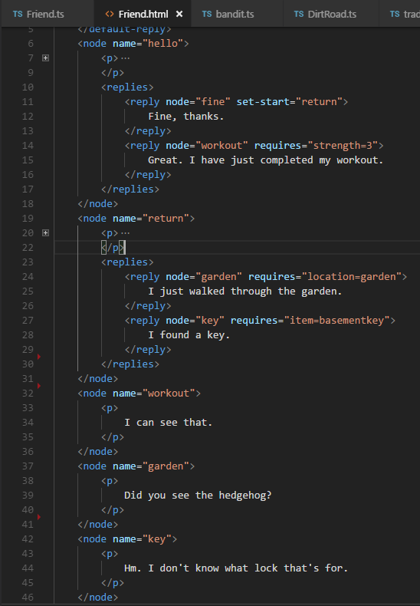
For your character to meet the strength requirement, you should select the first answer to both questions when creating a character. Go to the garden to talk to Joe about its inhabitants.
Try these requirements. Replies that you do not yet qualify for should be hidden from you. If you want them to show but unselectable, set the flag on the conversation in the .ts file like this:
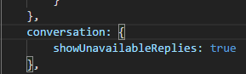

Triggering actions on replies
The last option of conversations to talk about in this chapter is triggering actions on selecting a specific reply. For this to work, you need to use the 'trigger' attribute with the name of the action to trigger on the reply in the .html file. The actual action you specify in the action collection on the conversation element in the .ts file.
Let's create an example. There is a hedgehog in the garden, but unless Joe told you about it you will not see it. To make this work, we add the trigger first in the .html file:
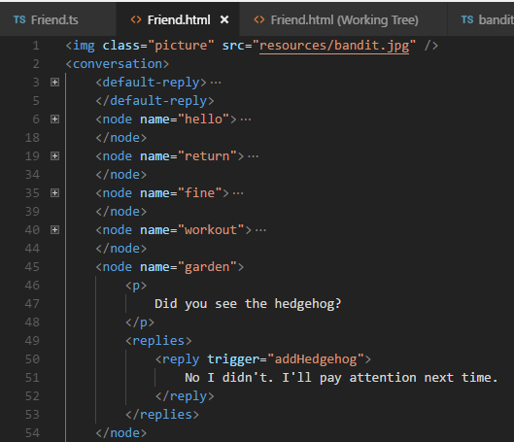
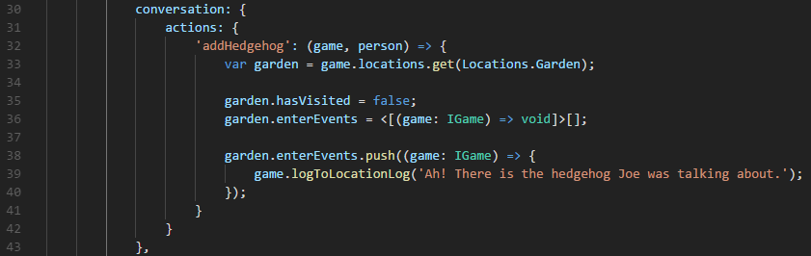
Second, we specify what the addHedgehog function does in the .ts file:

Note that I use a few tricks here to make this work. Events are run the first time the player visits a location, so I reset the hasVisitied flag on the Garden location first. Then I clear the events list, because the squirrel ran off the first time you visited the garden and it has not returned yet. Then, I add the new event to the Garden, writing a simple message to the location log.
Now, when you visit the garden, talk to Joe about it and return to the garden, you should see the hedgehog.

Trade and storage
As you build a world to explore and interact with, adding item stores is something you'll want to do sooner or later. Add a locker here, a chest there, and a store in the centre of a small village. Both storage and trade in StoryScript are handled by trade, where storage is a special form of trading where prices are zero and items can thus be moved to and from storage without changing anything else.
Trade can be added in two forms: either on a person (see chapter 12 on persons) or on a location. The syntax is the same, and the way it works as well but for a few small differences.
As an example, we'll add a personal closet to the bedroom, which has some items you can pick up there. You can also put items back in. This will demonstrate the basics of trading.
Open the bedroom.ts file and add the following code:
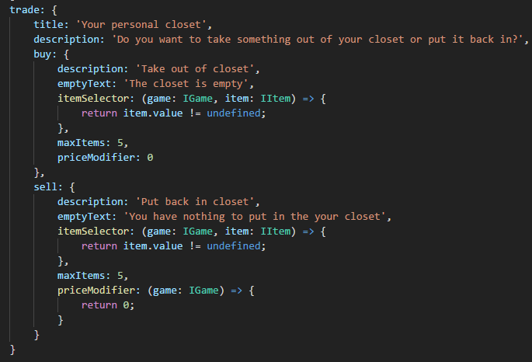

Go to the bedroom. You should see a button with the title specified in the trade code, and when you press it you should see the trade screen:
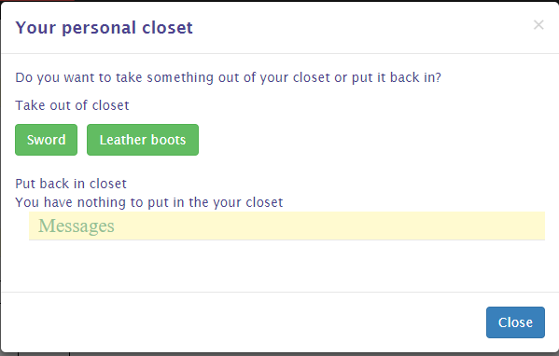
Ok, let's explore the options that are not obvious. First, you have both a buy and a sell side to the trade. This is defined from the perspective of the user, so the sell part is about the player 'selling' stuff to the trade object (in this case just putting his gear in the closet). Apart from the maxItems property, which determines the number of items available for buying or selling during one visit, Both buy and sell have two important properties:
- itemSelector. This is a function that returns the items that can be bought from the trader or sold to him, her or it. In this example, the items available for taking from the closet are all items in the game that have a value property. That's why the sword and the leather boots show up and not the basement key. The buy item selector by default will select from all the items you defined for your game. The sell item selector selects items only from your character's inventory, and will not include equipped items.
- PriceModifier: this can either be a number or a function that returns a number that will be multiplied by the item's value. For example, if you want the player to pay twice the value of an item to a trader in order to buy it, the number should be 2. In this example, the number on both sides is 0 because we want to put things in and take them out of the closet without paying any money.
Apart from a storage object or a store, you can also put the trade code on a person in order to be able to trade with that person. Let's enable trading with Joe by adding some code to the friend.js file:
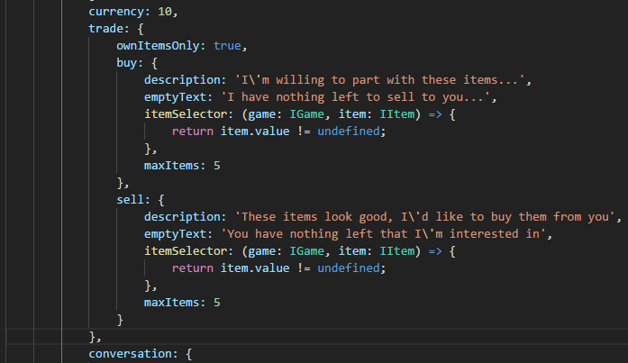
As you can see, I omitted the priceModifier here. That means Joe will buy and sell items for precisely their value.
Now you should be able to trade with Joe:
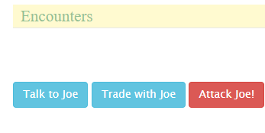
Some last things of note on trading are:
- currency. This will tell how much currency the trader has available for trading. NOTE: When trading with a person, the person's currency value is used. Traders can buy only as long as they have the money to pay for items that you have to offer. When you buy from them, the money you pay them will replenish their coffers.
- InitCollection: this is a function that is called before creating the list of items the trader has for sale. It returns true or false. If true is returned, the list of items for sale is refreshed. If not, the items that were on sale earlier will stay. If, for example, you want the trader's stock to be replenished based on some event, use this function to check whether the event has occurred and then return true for the list to be reinitialized.
- ownItemsOnly: this flag determines whether the itemSelector function will be applied to the items available in the game or the items in the trader's inventory. This way, you can allow the trader to sell only from his own gear and nothing else.

Quests
In any kind of story, the main character has to run errands or do favours. In StoryScript, these can be created as quests.
Let's add a little something we can do for Joe. Joe has misplaced his personal journal and he would really like to have it back. You can help him find it. Create a new folder 'quests' in your game's folder and add a file called journal.ts to it. Add this code:
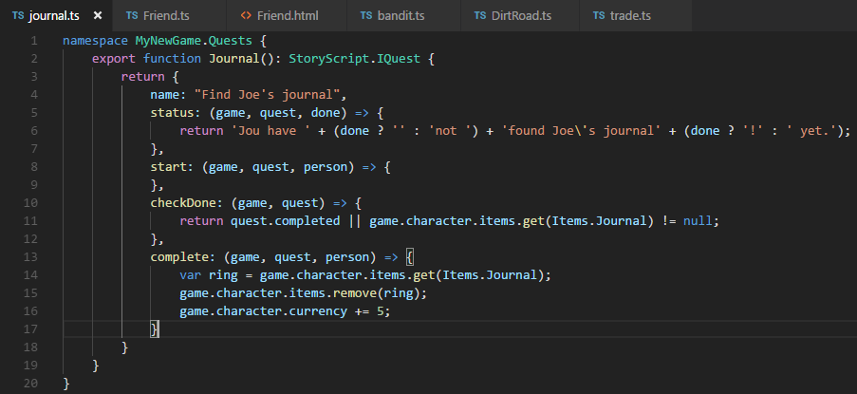
You can see that there are a number of elements to this. Apart from the quest name, there is an action you can run as soon as the quest starts. It is not used in this example. Further, there is a status property, which can be either a static text or a function returning some text, which tells what the current status of the quest is. Here, it'll format a message telling you whether or not you found Joe's journal.
Next, there is a function called to check whether the quest requirements are met called checkDone. It should return either true or false, depending on whether the player meets the quest requirements or not.
Finally, the complete function will trigger when the quest is completed and the reward claimed. Joe will give the player some cash when the journal is returned to him.
For this quest, I added a really simple quest item:
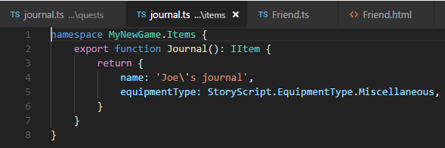
We have the elements that we need, no we need to wire them together. The simplest way to do this is to extend the conversation you can have with Joe with a few nodes and replies. First add a new reply when you come to see Joe for a second time:
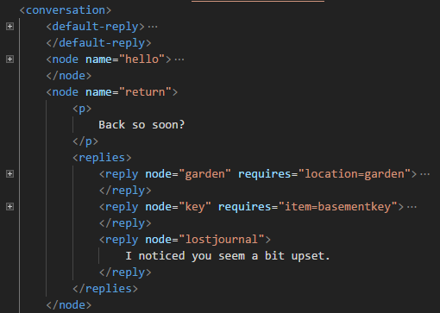
Then add the new nodes that are needed for the quest to unfold:
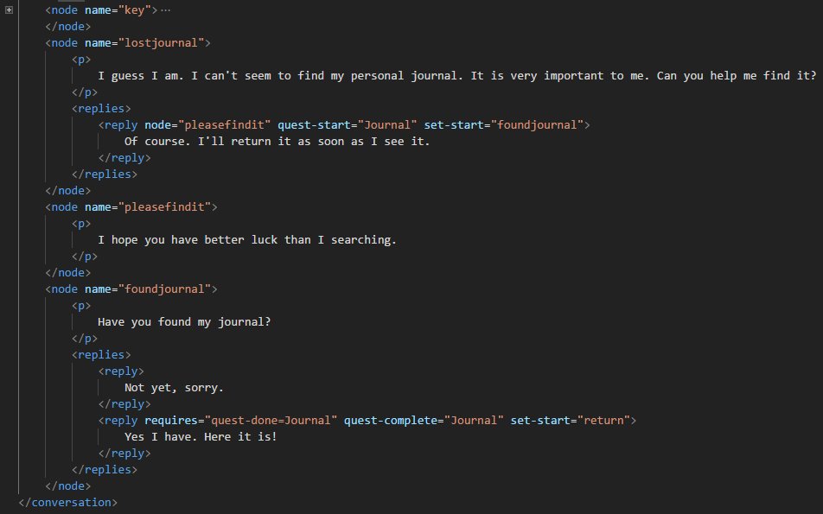
As you see, I used a few new reply attributes here, quest-start and quest-complete. These will trigger the start and complete functions of the quest whose name is specified, so the Journal quest in this case. Also, I added one of the quest-related requires attributes, in order not to show the reply that you found the journal until you actually have it in your possession. You can also use the quest-start and quest-complete requirements to show replies only when you started or completed a specific quest.
Now, we need add the quest to Joe in the friend.ts file:
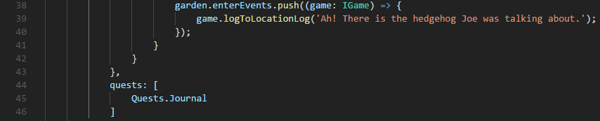
Ok, so Joe has a quest for us and we can talk to him to give it to us. You can test all of that by building and running the game. But we still need to put his journal somewhere in the game world for the player to find it and complete the quest. Let's add it to the basement location:
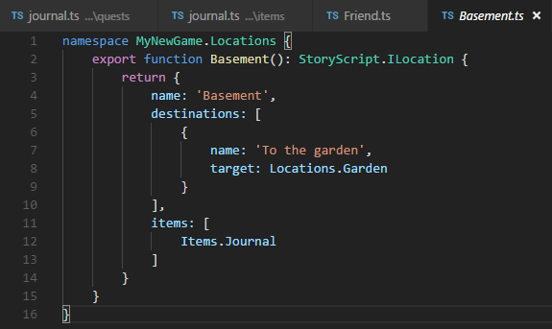
Now we have a nice quest ready for the player. He first has to talk to his friend and agree to help him. Then, he has to find the journal which is in the basement. To get in the basement, he needs a key. This key is in the possession of the bandit which he needs to defeat. Play the quest and return the journal to Joe. You should see something like this when you return to him:
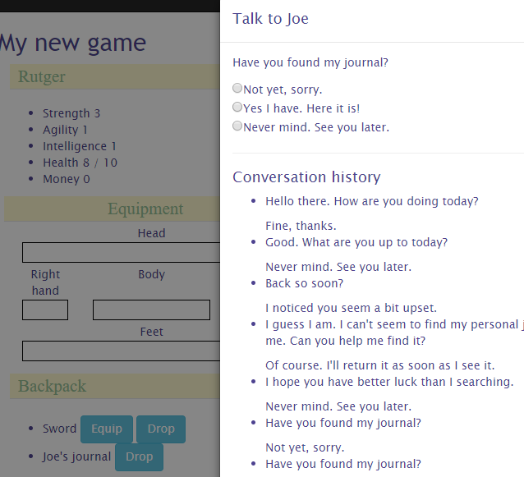
Give Joe his journal and you'll earn 5, erm, money...
Note that when you need to track progress on one of your quests, you can use the quest progress object. It is not typed, so you can add anything to it that you need. You can also check in code whether a quest is done by checking its completed flag.

Adding media

You can also add images to enemies and items. To add an image to the bandit, open the Bandit.ts file and add the pictureFileName property like this:
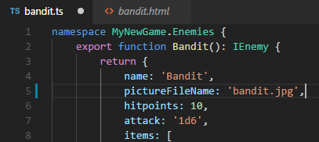
The bandit.jpg file needs to be present in the resources folder as well. Adding images to items works in the same way.
Go out on the road. The bad guy should now have a face!

Fleshing out items and enemies
In order to give your items and enemies a bit more substance, you can use an HTML file instead of a plain text description and a picture. With the HTML file, you can make them as flashy as you want. Unlike locations and persons, for items and enemies StoryScript does not assume descriptions are created in HTML files by default and will not look for them by default (there is a technical reason for this: all failed attempts result in a 404 status request in the browser which should not happen when everything works as expected). If you want to use an HTML description, use the special HTML constant as the description in your .ts file and create an HTML file with the same name as the .ts file. For the bandit, this looks like this:
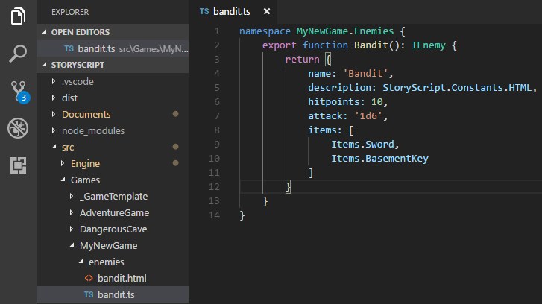
Once you're using an HTML file, it makes little sense to have to specify a picture for your enemy separately as it is so easily added there. If you add an image tag with the 'picture' class, StoryScript will take that image and show it for the enemy (it works the same for items):
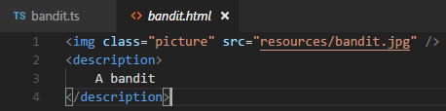

API
TODO: document features unless this can be done well in code.

